

Congratulations! You are now enrolled in a college
mathematics course. You should realize that you are
among a very special group of people. This math course
will require you to think, problem solve, and work hard
and fast. If you are willing to work hard, you will have
few problems. I want you to learn, but I also want you to
have fun along the way.
I will prepare you to take the AP Calculus test
CALCULUS AP EXAM TUESDAY, MAY 15 BE THERE ☺

The most important thing to remember is that you need to stay with me everyday. Do your homework. You will need your book. The calculus book gives a good explanation of the subject matter. Don't be afraid to ask questions. Remember that other people will have the same question, but are afraid to ask. I offer tutoring every morning and also after school. I arrive at 6:30 every day. I also offer a lunch tutorial during 5th period on Monday ,
Tuesday, Wednesday, and Thursday. Students can come to my room, each lunch , ask questions and work on homework. It is also possible to come during 7th period

MATERIALS NEEDED
1. Pencil or pen
2. Loose leaf paper
3 3-ring binder (hard or soft) or a folder for organization
4. Calculus textbook
5. Calculator (TI-83 or 84 or Inspire CX)
6. Box of Kleenex (required)
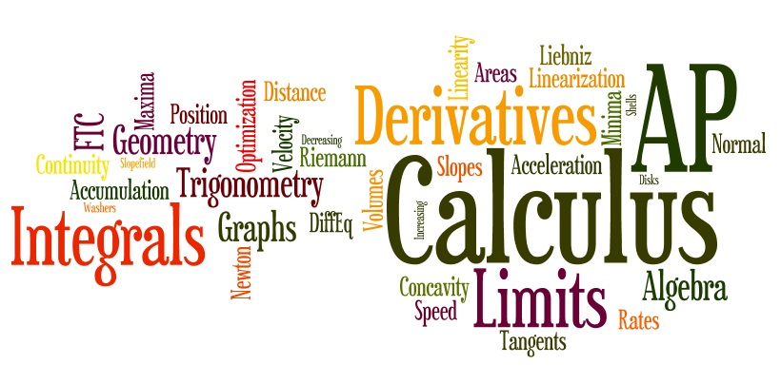

COURSE DESCRIPTION

Calculus AB is primarily concerned with developing the students' understanding of the concepts of calculus and providing experience with its methods and applications. The course emphasizes a multirepresentational approach to calculus, with concepts, results, and problems being expressed geometrically, numerically, analytically, and verbally. The focus of the course is neither manipulation nor memorization of an extensive taxonomy of functions, curves, theorems, or problem types. Technology can be used regularly by students to reinforce the relationships among the multiple representations of functions.

Below is a brief semester outline.

Semester 1 Semester 2

Analysis of Graphs Interpretations and properties of
Limits of functions definite integrals
Asymptotic and unbounded behavior Applications of integrals
Continuity as a property of functions Fundamental Theorem of Calculus
Concept of the derivative Techniques of antidifferentiation
Derivative at a point Applications of antidifferentiation
Derivative as a function Numerical approximations to
Second Derivatives Definite Integrals
Applications of derivatives Slope Fields
Computation of derivatives Integration techniques
L’Hopital’sRule Review for the AP exam

GRADING
QUIZZES/HOMEWORK/PROJECT 50%
TESTS 50%

